
A10
Sreenidhi Institute of Science & Technology
(An Autonomous Institution)
Code No: 101ME02
B. TECH. I – Year II – Semester Examinations, JUNE, 2014 (Supplementary)
ENGINEERING DRAWING – II (Common to All Branches)

Time: 3 Hours Max. Marks: 70

Note: No additional answer sheets will be provided.

Part - A (Objective Type)
Max.Marks:20

Answer all QUESTIONS.
1. What do you mean by key points? What is its significance in intersection of surfaces?
2. Name the methods of determining the curves of intersection.
3. Define ground plane and picture plane.
4. Differentiate between a transition piece and reducer.
6. List out the pictorial views.
7. Define CAD.
8. Name the coordinate systems.
9. What is the difference between isometric projection and oblique projection?
10. What is isometric scale?

Part – B
Max. Marks: 50
ANSWER ANY FIVE QUESTIONS. EACH QUESTION CARRIES 10 MARKS.

1. A cylinder of base diameter 70 mm and axis 120mm long is resting on its base on the H.P. It is penetrated by another cylinder of base diameter 60mm and axis 120 mm long such that their axes intersect each other at right angles. Draw the projections of the combination and show the curves of intersection.

2. A cone of base diameter 80mm and axis 100 mm, is resting on its base on the H.P. It is completely penetrated by a cylinder of base diameter 40mm and axis 100mm long. The axes of the solids intersect each other at right angles, 30mm above the base of the cone. Draw the projections of the combination and show curves of intersection.

3. Draw the isometric view of the below figure.
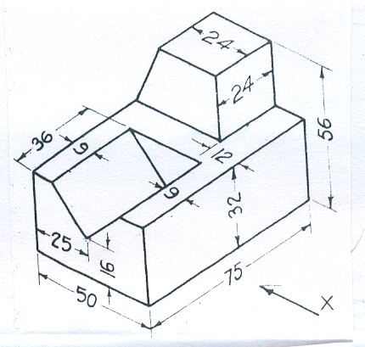

4. Draw the orthographic views of the below figure.

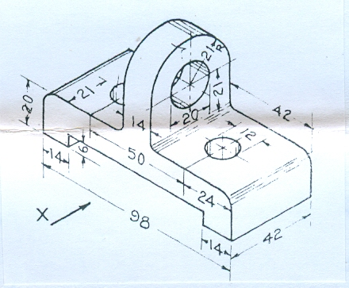

5. Draw the orthographic views to isometric view of the below figure.

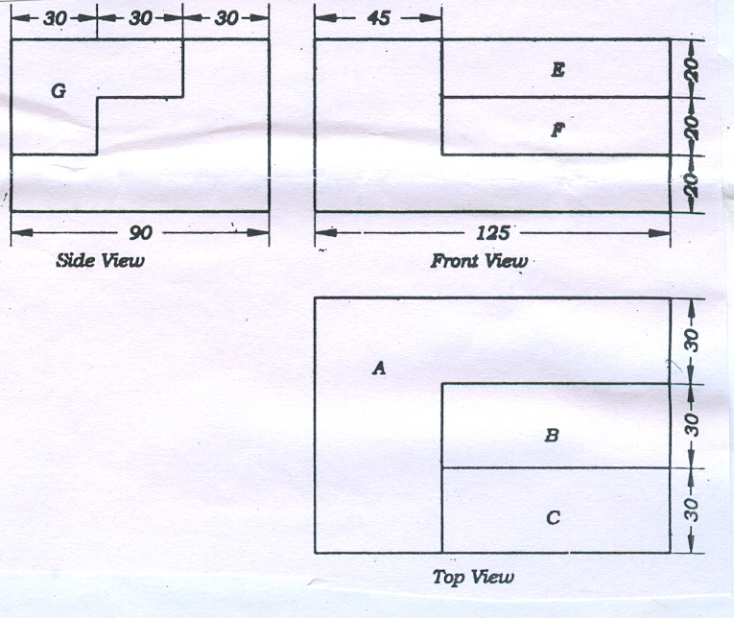

6. Draw the perspective projection of a straight line AB, 60mm long is parallel to and 10mm above the ground plane and inclined at 45º to PP. the end A is 20mm behind the picture plane. Station point is 35mm in front of the picture plane and 45mm above the ground plane and lies in a central plane passing through the mid point of AB.

7. A Square lamina of 40mm slide lies on the ground plane. One of its corners is touching the PP and an edge is inclined at 60ºto PP the station point is 40 mm infront of PP, 60mm above GP and lies in a central plane which is at a distance of 35 mm to the right of the corner touching the PP. Draw the perspective projection of the lamina.

8. a) What are the benefits and applications of CAD?
b) What are the input and output devices of CAD?

-- 00 -- 00 --

